****PUBLIC NOTICE****


CORINTH PARKS AND RECREATION BOARD SPECIAL
SESSION - CANCELLED
Wednesday, June 8, 2022 at 6:00 PM
Public Works | 1200 N. Corinth Street
Due to a lack of quorum, the meeting has been cancelled. Posted on this 7th day of June 2022, at 5:00 P.M., on the bulletin board at Corinth City Hall.
Posted on this 7th day of June 2022, at 5:00 P.M., on the bulletin board at Corinth City Hall.
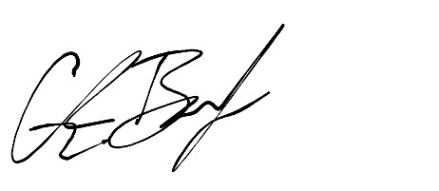

Glenn Barker

Director of Public Works

City of Corinth, Texas

